Software Requirements Specification
for
SUMMONERS WAR
Version 1.4
Prepared by Group 2
Creation Date: 21/10/2018
Table of Contents
Table of Contents 1
Revision History 2
Contributors…………………………………………………………………..………….……..3
1. Introduction 4
1.1 Purpose 4
1.2 Document Conventions 4
1.3 Intended Audience and Reading Suggestions 4
1.4 Product Scope 4
1.5 References 4
2. Overall Description 5
2.1 Product Perspective 5
2.2 Product Functions 5
2.3 User Classes and Characteristics 6
2.4 Operating Environment 6
2.5 Design and Implementation Constraints 6
2.6 User Documentation 6
2.7 Assumptions and Dependencies 6
3. External Interface Requirements 7
3.1 User Interfaces 7
3.2 Hardware Interfaces 7
3.3 Software Interfaces 7
3.4 Communications Interfaces 7
4. System Features 8
4.1 Login 9
4.2 SignUp 9
4.3 Logout 9
4.4 FAQ 10
4.5 Report a problem 10
4.6 View Ticket History 10
4.7 Admin Login 11
4.8 Admin Logout 11
4.9 View List Of Errors 11
4.10 Create Tickets 12
4.11 Send Ticket To Corresponding Section 12
4.12 Change Ticket Status 12
4.13 Reply To Users 13

5. Other Nonfunctional Requirements 13
5.1 Performance Requirements 14
5.2 Safety Requirements 14
5.3 Security Requirements 14
5.4 Software Quality Attributes 14
5.5 Business Rules 14
6. Other Requirements 14
Appendix A: Glossary 14
Appendix B: Analysis Models 14
Functional Relations 14
Data Flow 15

Revision History
Name | Date | Reason For Changes | Version
Software Requirements Specification for Summoners War | 21/10/18 | - Introduction, overall description. | 1.0
Software Requirements Specification for Summoners War | 28/10/18 | - Separating contact form and ticket form.  - Ticket is being made by the tech support rather than the user.  - Interface for the tech support is added. | 1.1
Software Requirements Specification for Summoners War | 30/10/18 | - External Interface Requirements, system features. | 1.2
Software Requirements Specification for Summoners War | 31/10/18 | - Other nonfunctional requirements. | 1.3
Software Requirements Specification for Summoners War | 1/11/18 | - Appendixes, overall changes. | 1.4

Contributors

Name | Email-id
Yoav Yung | Joaffzie@gmail.com
Harel Jerbi | Harel.jerbi1@gmail.com
Shai Shitrit | Shai2221712@walla.com
Yariv Garala | yariv1052@gmail.com
Michael Biton | michaelbiton40@gmail.com
George Djabarov | 963gosha@gmail.com
Yakir Kobaivanov | yakirk1@gmail.com

Mentors

- Mr. Bnaya Sand.
- Mrs. Shani Levi.

Introduction

Purpose
The purpose of this document is to present a detailed description of Summoners War tech support System. It will explain the purpose and features of the system, the interfaces of the system, what the system will do and the constraints under which it must operate.

Document Conventions
This document doesn’t follow any formal format styles.

Intended Audience and Reading Suggestions
This document will be the first guide to prospective software developers, project managers and testers of Summoners War.
This document contains software functionality& requirements.

- Developer: The developer who wants to read, change, modify or add new requirements into the existing program may need first to consult this document and update the requirements.
- Tester: The tester needs this document to prepare his test cases to validate that the initial requirements of this project are implemented.

Product Scope

With the continued growth in popularity of Summoners War, the need of an efficient problem handling system became more essential., where users can report their issues that they’re facing in a better way.
Summoners War support system provides a convenient and easy-way-to-use system that handles getting information from users which will turn into support tickets by the support team.
This ticketing system will greatly benefit Summoners War's team in all sorts of aspects; Problem solving, tracing user complaints and overall developing a game in a better, more organized environment.

References
No references.

Overall Description

Product Perspective
The product is supposed to be a CSS. It is a CMD based system implemented by C.
The Summoners War Ticketing System provides a simple way for users to report their issues and a quick and efficient way for the tech team to track and respond to said issues.

The followings are the main features that are included in Summoners War's Ticketing System:

- User account: The system allows the user to create their accounts in the system.
- Number of users being supported by the system: Though the number is not precisely mentioned but the system is able to support a large number of users.
- Ticketing system: Allows users to submit their issues to the Admin in case their issues are not solved by the FAQs.
- Status check: Users can check their tickets' statuses at any given time.
- FAQs section: Contains answers of problems which are frequently asked.

Product Functions
Summoners War's Ticketing System functions are categorized in two different groups:
- User features:
  - Login
  - Sign up
  - Logout
  - FAQ
  - Report a problem
  - View ticket history
- Admin features:
  - Login
  - Logout
  - View list of user reports
  - Create tickets based on user reports
  - Send tickets to corresponding sections
  - Change ticket status
  - Reply to users

User Classes and Characteristics
Users should have the basic knowledge of operating a computer and having access to internet connection. The administrators are expected to be familiar with the interface of the tech support system.

Operating Environment
The software will be developed in Microsoft's OS. The software will be developed in C programming language. Required hardware is mainly hard disks for storing data. The software will be able to operate in Windows7,Windows 8/.1/.2/.3 and Windows10.

Design and Implementation Constraints
This system is provisioned to be built on C programming language which in one hand is extremely efficient in terms of performance and memory usage but doesn’t fully support objects and classes which may backfire in terms of options to develop. Moreover, our time as developers is extremely limited which may cause our developing schedule to be interrupted.

User Documentation
Not relevant, there are no user manuals or online help other than the FAQ listed in this SRS.

Assumptions and Dependencies
There are no external dependencies.

External Interface Requirements

User Interfaces
User interface is included in the prototype.

Hardware Interfaces
Not relevant, the hardware being used are hard disks.

Software Interfaces
This software works solely on its own,it doesn’t connect to external sources. The system does NOT take its info from Summoner War’s database. We are two separated units that work together.

Communications Interfaces
This software doesn’t work online therefore doesn’t require or need an actual communication system. An admin can leave a reply in a user’s opened ticked but not in real-time.

System Features
Major user features:

Login
4.1.1 User& Admin login to the ticketing system (High)
Priority components:
-Benefit: Logging in into a private account makes sure users' tickets are secured and protected. (9)
-Risk: In case of logging issues, players won't be able to report their issues which may lead to players quitting the game because of unresolved bugs. (9)
4.1.2 Stimulus/Response Sequences
When the user presses the login button, he will be redirected to a new screen asking for a valid username& password. After filling the info, a check occurs using the database and if the info was correct, the user may login.
4.1.3 Functional Requirements
The execute this feature our software must be able to take the user’s info correctly, and to be able to hold under stress in case of a lot of incoming requests to login. In case of bad input the user will not be able to login and will be requested to fill in account info again.

Sign Up
4.2.1 Account creation for new users (High)
Priority components:
-Benefit: Being able to create a new account for new users who may encounter problems is extremely important. (9)
-Risk: Allowing users to create accounts may cause problems in case of malicious usage. (9)
4.2.2 Stimulus/Response Sequences
When the user presses the sign-up button, he will be redirected into a user contact form page. The user fills in relevant information and upon completion his account will be stored in the user database.
4.2.3 Functional Requirements
In order for the sign up feature to be working the system will need to be able to withstand many accounts at the same time. Bad input will require the user re-enter his info and the account will not be created.

Logout
4.3.1 Account signing out (Low)
Priority components:
-Benefit: Having the option to sign out of a logged account is comfortable for users who share a computer with other people and don't want their account to be seen by all users of said computer. (3)
-Risk: Not having the option to sign out may lead to overflow in terms of system performance (too many users signed in). (6)
4.3.2 Stimulus/Response Sequences
When the user presses the sign out button he logs out of his account and is redirected to the main screen.
4.3.3 Functional Requirements
Not relevant.

FAQ
4.4.1 Commonly asked questions (Low)
Priority components:
-Benefit: Users may solve quickly their issues via the FAQ section, not needing to create an account& submit errors. (4)
-Risk: No risk. (0)
4.4.2 Stimulus/Response Sequences
When the user presses the FAQ button he will be redirected to the FAQ screen.
4.4.3 Functional Requirements
Not relevant.

Report a problem
4.2.1 Users report their problems (High)
Priority components:
-Benefit: The whole purpose of the ticketing system is to have the users report their problems in an easy, efficient way. (9)
-Risk: No risks. (0)
4.2.2 Stimulus/Response Sequences
The user reports his issues after he logs in, he describes the problem and submits it.
4.2.3 Functional Requirements
The software must be able to take the user’s problem and transmit it to the list of existing pre-ticked errors.

View ticket history
4.6.1 A list of previous existing tickets (Medium)
Priority components:
-Benefit: Being able to view and check previous solved tickets may help a user to determine current problems. (6)
-Risk: No risk. (0)
4.6.2 Stimulus/Response Sequences
When the user presses the option to view the previous tickets, a screen will be shown with the previous tickets.
4.6.3 Functional Requirements
This function requires the database to correctly present info based on individual accounts.

Major Admin Functions

Login
Listed above.

Logout
Listed above.

View list of user reports
4.9.1 View list of user reports (High)
Priority components:
-Benefit: Being able to see a list of problems makes things easier for the admins to classify errors. (9)
-Risk: No risks. (0)
4.9.2 Stimulus/Response Sequences
When the Admin logs in, he can choose to view a list of existing problems that were sent by the users.
4.9.3 Functional Requirements
This function requires the database to correctly present info and list the current sent errors by the users.

Create tickets based on user reports
4.10.1 Create tickets based on user reports (High)
Priority components:
-Benefit: Sole purpose of this software is for admins to open tickets based on user reports, this is more of a demand rather than a benefit. (9)
-Risk: No risks. (0)
4.10.2 Stimulus/Response Sequences
When the admin what error he wants to work on from the list, a screen will be shown that enabled him to make a ticket out of an error.
4.10.3 Functional Requirements
This function requires the database to be able to store new tickets.

Send ticket to corresponding section
4.11.1 Send ticket to corresponding section (High)
Priority components:
-Benefit: Sending the tickets to the section in charge saves a lot of time in the process of solving a problem. (9)
-Risk: No risks. (0)
4.11.2 Stimulus/Response Sequences
When the admin makes a new ticket out of an error, he will be responsible for sending it to the right section via a dedicated screen.
4.11.3 Functional Requirements
Not relevant.

Change ticket status
4.12.1 Change ticket status (Medium)
Priority components:
-Benefit: Changing a status provides relevant information for the awaiting user. (6)
-Risk: No risks. (0)
4.12.2 Stimulus/Response Sequences
The admin has the option to change a ticket status: Closed/Ongoing/etc.
4.12.3 Functional Requirements
This function requires the ticketing system to work so a ticket could be edited.

Reply to users
4.13.1 Reply to user (Medium)
Priority components:
-Benefit: Replying to users can motivate users to use the system more. (9)
-Risk: No risks. (0)
4.13.2 Stimulus/Response Sequences
When the user presses the sign-up button, he will be redirected into a user contact form page. The user fills in relevant information and upon completion his account will be stored in the user database.
4.13.3 Functional Requirements
This function requires the ticketing system to work so a ticket could be edited and be left with the admin’s reply.

Other Nonfunctional Requirements

Performance Requirements
There are no performance requirements.

Safety Requirements
Not relevant.

Security Requirements
We make sure accounts are separated and unique, each account has its own username to make sure privacy is kept and users do not have the option to see each other’s tickets.

Software Quality Attributes
The software will be manually updated and adjusted with future needs. Testers will be able to test the game and report problems in order to fix and check certain things that couldn’t be checked otherwise.

Business Rules
Not relevant.

Other Requirements
No other requirements.
Appendix A: Glossary
C- A programming language.
SRS – Software requirements specification.
FAQ – Frequently asked questions.
Admin – A staff member of the tech team.
OS – Operating system
Microsoft – Microsoft Corporation is an American multinational technology company
Windows – Refers to Microsoft’s famous operating system.
Ticket – service request from an end-user that is received by a ticketing system.
Appendix B: Analysis Models

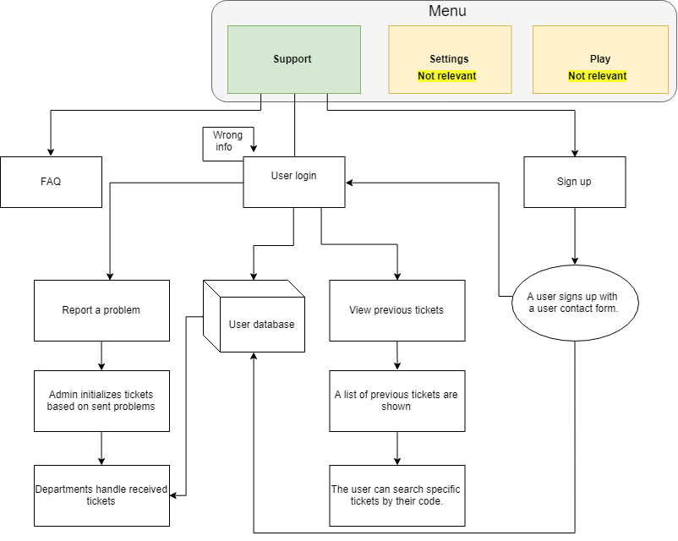
Functional relations:

Data Flow:

